**DC MOTOR**

**BLOCK:** Output

**ANALOG/DIGITAL:** Digital

**PHOTO/CIRCUIT SYMBOL:**

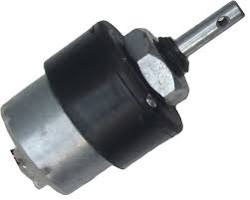 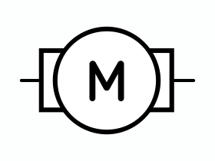

**DESCRIPTION:**

In any electric motor, operation is based on simple electromagnetism. A current-carrying conductor generates a magnetic field; when this is then placed in an external magnetic field, it will experience a force proportional to the current in the conductor, and to the strength of the external magnetic field. The internal configuration of a DC motor is designed to harness the magnetic interaction between a current-carrying conductor and an external magnetic field to generate rotational motion.

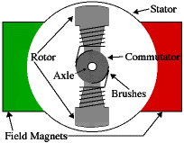

In a simple 2-pole DC electric motor, as shown above (here red (right side) represents a magnet or winding with a "North" polarization, while green (left side) represents a magnet or winding with a "South" polarization).

Every DC motor has six basic parts axle, rotor (a.k.a., armature), stator, commutator, field magnet(s), and brushes. In most common DC motors (and all that Beamers will see), the external magnetic field is produced by high-strength permanent magnets.

The stator is the stationary part of the motor this includes the motor casing, as well as two or more permanent magnet pole pieces. The rotor (together with the axle and attached commutator) rotates with respect to the stator. The rotor consists of windings (generally on a core), the windings being electrically connected to the commutator. The above diagram shows a common motor layout with the rotor inside the stator (field) magnets.

The geometry of the brushes, commutator contacts, and rotor windings are such that when power is applied, the polarities of the energized winding and the stator magnet(s) are misaligned, and the rotor will rotate until it is almost aligned with the stator's field magnets. As the rotor reaches alignment, the brushes move to the next commutator contacts, and energize the next winding. Given our example two-pole motor, the rotation reverses the direction of current through the rotor winding, leading to a "flip" of the rotor's magnetic field, driving it to continue rotating.

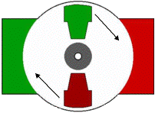

In real life, though, DC motors will always have more than two poles (three is a very common number). In particular, this avoids "dead spots" in the commutator. You can imagine how with our example two-pole motor, if the rotor is exactly at the middle of its rotation (perfectly aligned with the field magnets); it will get "stuck" there. Meanwhile, with a two-pole motor, there is a moment where the commutator shorts out the power supply (i.e., both brushes touch both commutator contacts simultaneously). This would be bad for the power supply, waste energy, and damage motor components as well. Yet another disadvantage of such a simple motor is that it would exhibit a high amount of torque "ripple" (the amount of torque it could produce is cyclic with the position of the rotor).

Interfacing a DC motor with a microcontroller. Usually H-bridge is preferred way of interfacing a DC motor. These days many IC manufacturers have H-bridge motor drivers available in the market like L293D is most used H-Bridge driver IC. H-bridge can also be made with the help of transistors and MOSFETs etc. rather of being cheap, they only increase the size of the design board, which is sometimes not required so using a small 16 pin IC is preferred for this purpose.

**Working Theory of H-Bridge**

The name "H-Bridge" is derived from the actual shape of the switching circuit which control the motion of the motor. It is also known as "Full Bridge". Basically there are four switching elements in the H-Bridge as shown in the figure below.

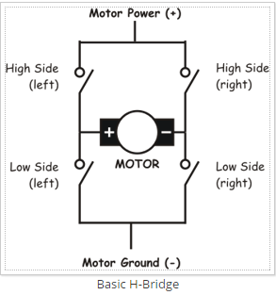

As you can see in the figure above there are four switching elements named as "High side left", "High side right", "Low side right", "Low side left". When these switches are turned on in pairs motor changes its direction accordingly. Like, if we switch on High side left and Low side right then motor rotate in forward direction, as current flows from Power supply through the motor coil goes to ground via switch low side right. This is shown in the figure below.

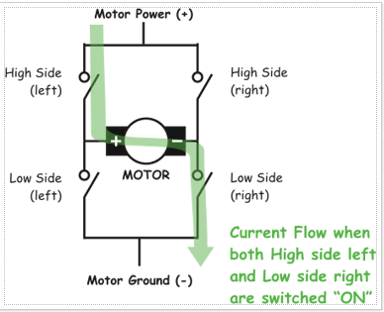

Similarly, when you switch on low side left and high side right, the current flows in opposite direction and motor rotates in backward direction. This is the basic working of H-Bridge. We can also make a small truth table according to the switching of H-Bridge explained above.

| **High Left** | **High Right** | **Low Left** | **Low Right** | **Description** |
| --- | --- | --- | --- | --- |
| On | Off | Off | On | Motor runs clockwise |
| Off | On | On | Off | Motor runs anti-clockwise |
| On | On | Off | Off | Motor stops or decelerates |
| Off | Off | On | On | Motor stops or decelerates |

**POSSIBILITY:**

* Boring mills
* Shapers
* Spinning and Weaving machines.
* Elevators
* Air compressor